1. Doplň: catch, 2. smoke, 3. pass, 4. stay, 5. not live, 6. fix, 7. buy, 8. play

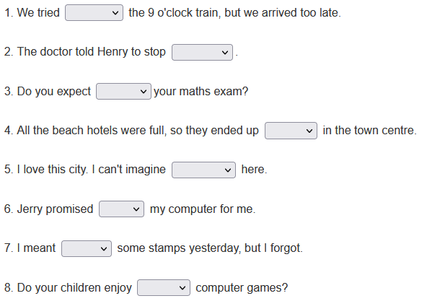

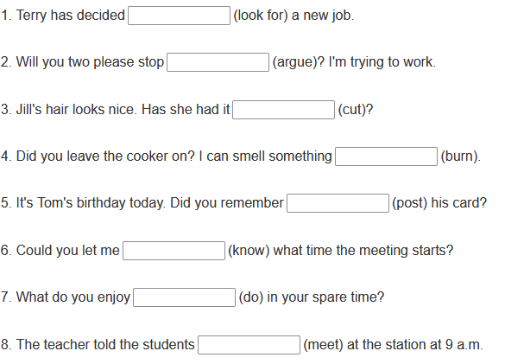

Did you tell her you loved her? No, but I .................................... (want).

Why did you take the medicine? Because the doctor................................. (tell me).

Why are you going to help Sue? Because I .................................. (promise).

Are you going to sell your house? Yes, I’ve ..................................... (decide).

Will you come to the party with me? I’d ............................................... (love).

Why didn’t you text me? Sorry, I ....................................... (forget).